How to generate Rest API using Swagger

Follow the below Steps:

First develop your full application using Spring-MVC-Rest, don’t bother about swagger configuration and all.

After development follow steps.

Steps:

1. Add dependency in your pom.xml for swagger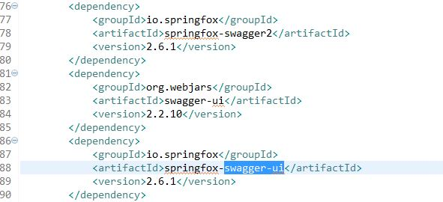
2. Add the path of swagger UI in web.xml or in java base config class as below

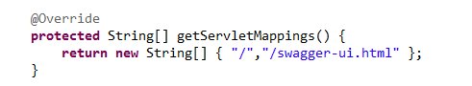

1. Download swagger UI from below link and save, extract it u will get below structure

Download link: <https://github.com/swagger-api/swagger-ui>

After download go to the dist folder make sure u will get below structure

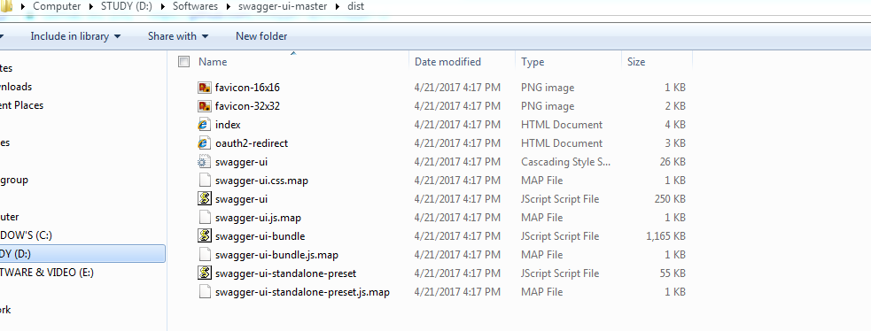

Then copy above all 12 files to your application webapp folder as below

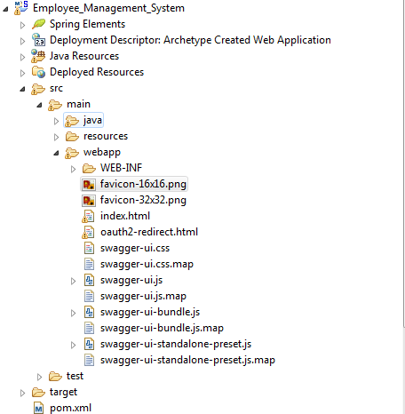

1. Write your Java base configuration class to enable Swagger features and add API information to display on swagger-ui.html as below

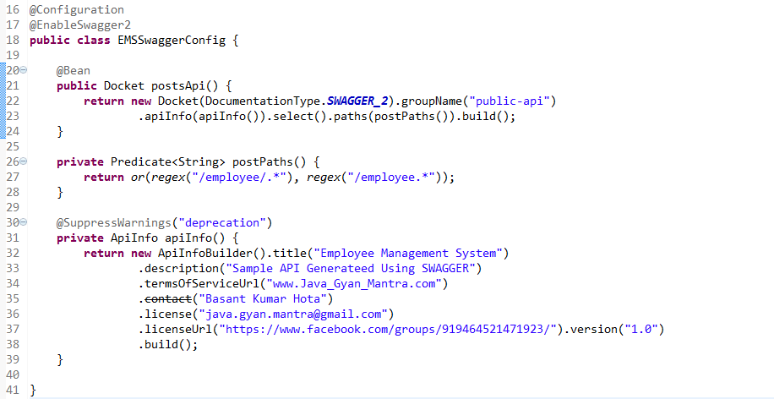

1. Deploy your application and run in server.

Then run <http://localhost:8080/ProjectName/swagger-ui.html>

You will get below graphical image for our Rest API.

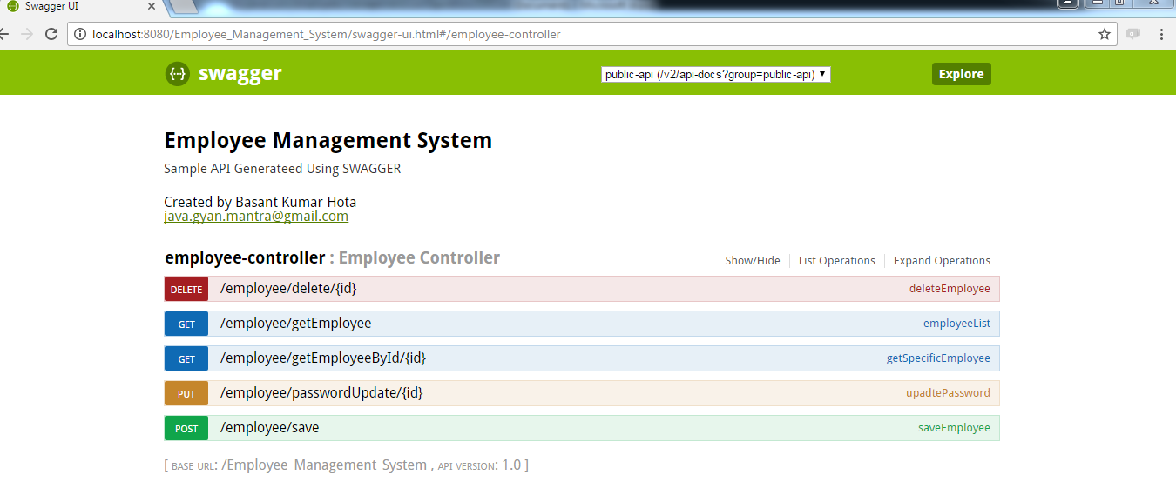

That’s it in Spring MVC.

If you are using spring boot then no need to do all stuffs.

Only required step is (1, 4)

Regards,

Basanta Kumar Hota